Първа секвенция

MSNPFAHLAEPLDPVQPGKKFFNLNKLEDSRYGRLPFSIRVLLEAAIRNCDEFLVKKQDI

ENILHWNVTQHKNIEVPFKPARVILQDFTGVPAVVDFAAMRDAVKKLGGDPEKINPVCPA

DLVIDHSIQVDFNRRADSLQKNQDLEFERNRERFEFLKWGSQAFHNMRIIPPGSGIIHQV

NLEYLARVVFDQDGYYYPDSLVGTDSHTTMIDGLGILGWGVGGIEAEAVMLGQPISMVLP

QVIGYRLMGKPHPLVTSTDIVLTITKHLRQVGVVGKFVEFFGPGVAQLSIADRATIANMC

PEYGATAAFFPVDEVSITYLVQTGRDEEKLKYIKKYLQAVGMFRDFNDPSQDPDFTQVVE

LDLKTVVPCCSGPKRPQDKVAVSDMKKDFESCLGAKQGFKGFQVAPEHHNDHKTFIYDNT

EFTLAHGSVVIAAITSCTNTSNPSVMLGAGLLAKKAVDAGLNVMPYIKTSLSPGSGVVTY

YLQESGVMPYLSQLGFDVVGYGCMTCIGNSGPLPEPVVEAITQGDLVAVGVLSGNRNFEG

RVHPNTRANYLASPPLVIAYAIAGTIRIDFEKEPLGVNAKGQQVFLKDIWPTRDEIQAVE

RQYVIPGMFKEVYQKIETVNESWNALATPSDKLFFWNSKSTYIKSPPFFENLTLDLQPPK

SIVDAYVLLNLGDSVTTDHISPAGNIARNSPAARYLTNRGLTPREFNSYGSRRGNDAVMA

RGTFANIRLLNRFLNKQAPQTIHLPSGEILDVFDAAERYQQAGLPLIVLAGKEYGAGSSR

DWAAKGPFLLGIKAVLAESYERIHRSNLVGMGVIPLEYLPGENADALGLTGQERYTIIIP

ENLKPQMKVQVKLDTGKTFQAVMRFDTDVELTYFLNGGILNYMIRKMAK

NCBI

cytoplasmic aconitate hydratase [Homo sapiens]

Query 1 MSNPFAHLAEPLDPVQPGKKFFNLNKLEDSRYGRLPFSIRVLLEAAIRNCDEFLVKKQDI 60

MSNPFAHLAEPLDPVQPGKKFFNLNKLEDSRYGRLPFSIRVLLEAAIRNCDEFLVKKQDI

Sbjct 1 MSNPFAHLAEPLDPVQPGKKFFNLNKLEDSRYGRLPFSIRVLLEAAIRNCDEFLVKKQDI 60

Query 61 ENILHWNVTQHKNIEVPFKPARVILQDFTGVPAVVDFAAMRDAVKKLGGDPEKINPVCPA 120

ENILHWNVTQHKNIEVPFKPARVILQDFTGVPAVVDFAAMRDAVKKLGGDPEKINPVCPA

Sbjct 61 ENILHWNVTQHKNIEVPFKPARVILQDFTGVPAVVDFAAMRDAVKKLGGDPEKINPVCPA 120

Query 121 DLVIDHSIQVDFNRRADSLQKNQDLEFERNRERFEFLKWGSQAFHNMRIIPPGSGIIHQV 180

DLVIDHSIQVDFNRRADSLQKNQDLEFERNRERFEFLKWGSQAFHNMRIIPPGSGIIHQV

Sbjct 121 DLVIDHSIQVDFNRRADSLQKNQDLEFERNRERFEFLKWGSQAFHNMRIIPPGSGIIHQV 180

Query 181 NLEYLARVVFDQDGYYYPDSLVGTDSHTTMIDGLGILGWGVGGIEAEAVMLGQPISMVLP 240

NLEYLARVVFDQDGYYYPDSLVGTDSHTTMIDGLGILGWGVGGIEAEAVMLGQPISMVLP

Sbjct 181 NLEYLARVVFDQDGYYYPDSLVGTDSHTTMIDGLGILGWGVGGIEAEAVMLGQPISMVLP 240

Query 241 QVIGYRLMGKPHPLVTSTDIVLTITKHLRQVGVVGKFVEFFGPGVAQLSIADRATIANMC 300

QVIGYRLMGKPHPLVTSTDIVLTITKHLRQVGVVGKFVEFFGPGVAQLSIADRATIANMC

Sbjct 241 QVIGYRLMGKPHPLVTSTDIVLTITKHLRQVGVVGKFVEFFGPGVAQLSIADRATIANMC 300

Query 301 PEYGATAAFFPVDEVSITYLVQTGRDEEKLKYIKKYLQAVGMFRDFNDPSQDPDFTQVVE 360

PEYGATAAFFPVDEVSITYLVQTGRDEEKLKYIKKYLQAVGMFRDFNDPSQDPDFTQVVE

Sbjct 301 PEYGATAAFFPVDEVSITYLVQTGRDEEKLKYIKKYLQAVGMFRDFNDPSQDPDFTQVVE 360

Query 361 LDLKTVVPCCSGPKRPQDKVAVSDMKKDFESCLGAKQGFKGFQVAPEHHNDHKTFIYDNT 420

LDLKTVVPCCSGPKRPQDKVAVSDMKKDFESCLGAKQGFKGFQVAPEHHNDHKTFIYDNT

Sbjct 361 LDLKTVVPCCSGPKRPQDKVAVSDMKKDFESCLGAKQGFKGFQVAPEHHNDHKTFIYDNT 420

Query 421 EFTLAHGSVVIAAITSCTNTSNPSVMLGAGLLAKKAVDAGLNVMPYIKTSLSPGSGVVTY 480

EFTLAHGSVVIAAITSCTNTSNPSVMLGAGLLAKKAVDAGLNVMPYIKTSLSPGSGVVTY

Sbjct 421 EFTLAHGSVVIAAITSCTNTSNPSVMLGAGLLAKKAVDAGLNVMPYIKTSLSPGSGVVTY 480

Query 481 YLQESGVMPYLSQLGFDVVGYGCMTCIGNSGPLPEPVVEAITQGDLVAVGVLSGNRNFEG 540

YLQESGVMPYLSQLGFDVVGYGCMTCIGNSGPLPEPVVEAITQGDLVAVGVLSGNRNFEG

Sbjct 481 YLQESGVMPYLSQLGFDVVGYGCMTCIGNSGPLPEPVVEAITQGDLVAVGVLSGNRNFEG 540

Query 541 RVHPNTRANYLASPPLVIAYAIAGTIRIDFEKEPLGVNAKGQQVFLKDIWPTRDEIQAVE 600

RVHPNTRANYLASPPLVIAYAIAGTIRIDFEKEPLGVNAKGQQVFLKDIWPTRDEIQAVE

Sbjct 541 RVHPNTRANYLASPPLVIAYAIAGTIRIDFEKEPLGVNAKGQQVFLKDIWPTRDEIQAVE 600

Query 601 RQYVIPGMFKEVYQKIETVNESWNALATPSDKLFFWNSKSTYIKSPPFFENLTLDLQPPK 660

RQYVIPGMFKEVYQKIETVNESWNALATPSDKLFFWNSKSTYIKSPPFFENLTLDLQPPK

Sbjct 601 RQYVIPGMFKEVYQKIETVNESWNALATPSDKLFFWNSKSTYIKSPPFFENLTLDLQPPK 660

Query 661 SIVDAYVLLNLGDSVTTDHISPAGNIARNSPAARYLTNRGLTPREFNSYGSRRGNDAVMA 720

SIVDAYVLLNLGDSVTTDHISPAGNIARNSPAARYLTNRGLTPREFNSYGSRRGNDAVMA

Sbjct 661 SIVDAYVLLNLGDSVTTDHISPAGNIARNSPAARYLTNRGLTPREFNSYGSRRGNDAVMA 720

Query 721 RGTFANIRLLNRFLNKQAPQTIHLPSGEILDVFDAAERYQQAGLPLIVLAGKEYGAGSSR 780

RGTFANIRLLNRFLNKQAPQTIHLPSGEILDVFDAAERYQQAGLPLIVLAGKEYGAGSSR

Sbjct 721 RGTFANIRLLNRFLNKQAPQTIHLPSGEILDVFDAAERYQQAGLPLIVLAGKEYGAGSSR 780

Query 781 DWAAKGPFLLGIKAVLAESYERIHRSNLVGMGVIPLEYLPGENADALGLTGQERYTIIIP 840

DWAAKGPFLLGIKAVLAESYERIHRSNLVGMGVIPLEYLPGENADALGLTGQERYTIIIP

Sbjct 781 DWAAKGPFLLGIKAVLAESYERIHRSNLVGMGVIPLEYLPGENADALGLTGQERYTIIIP 840

Query 841 ENLKPQMKVQVKLDTGKTFQAVMRFDTDVELTYFLNGGILNYMIRKMAK 889

ENLKPQMKVQVKLDTGKTFQAVMRFDTDVELTYFLNGGILNYMIRKMAK

Sbjct 841 ENLKPQMKVQVKLDTGKTFQAVMRFDTDVELTYFLNGGILNYMIRKMAK 889

<https://www.genome.jp>

**KEGG GENES**

[ptr:465034](https://www.genome.jp/dbget-bin/www_bget?ptr:465034)

K01681 aconitate hydratase [EC:4.2.1.3] | (RefSeq) ACO1; cytoplasmic aconitate hydratase isoform X1

[ggo:101132086](https://www.genome.jp/dbget-bin/www_bget?ggo:101132086)

K01681 aconitate hydratase [EC:4.2.1.3] | (RefSeq) ACO1; cytoplasmic aconitate hydratase isoform X1

[pon:100173767](https://www.genome.jp/dbget-bin/www_bget?pon:100173767)

K01681 aconitate hydratase [EC:4.2.1.3] | (RefSeq) ACO1; cytoplasmic aconitate hydratase

[nle:100607117](https://www.genome.jp/dbget-bin/www_bget?nle:100607117)

K01681 aconitate hydratase [EC:4.2.1.3] | (RefSeq) ACO1; cytoplasmic aconitate hydratase isoform X1

[mcc:705075](https://www.genome.jp/dbget-bin/www_bget?mcc:705075)

K01681 aconitate hydratase [EC:4.2.1.3] | (RefSeq) ACO1; cytoplasmic aconitate hydratase

<https://reactome.org> и https://www.ebi.ac.uk

Genes and Transcripts

[**enoyl-CoA hydratase**](https://reactome.org/content/detail/R-HSA-70827)

**Identifier:** R-HSA-70827

**Species:** Homo sapiens

**Compartment:** mitochondrial matrix

**Cellular Component**

##### Definition ([GO:0005759 GONUTS page](http://gowiki.tamu.edu/wiki/index.php/Category:GO:0005759))

The gel-like material, with considerable fine structure, that lies in the matrix space, or lumen, of a mitochondrion. It contains the enzymes of the tricarboxylic acid cycle and, in some organisms, the enzymes concerned with fatty acid oxidation.

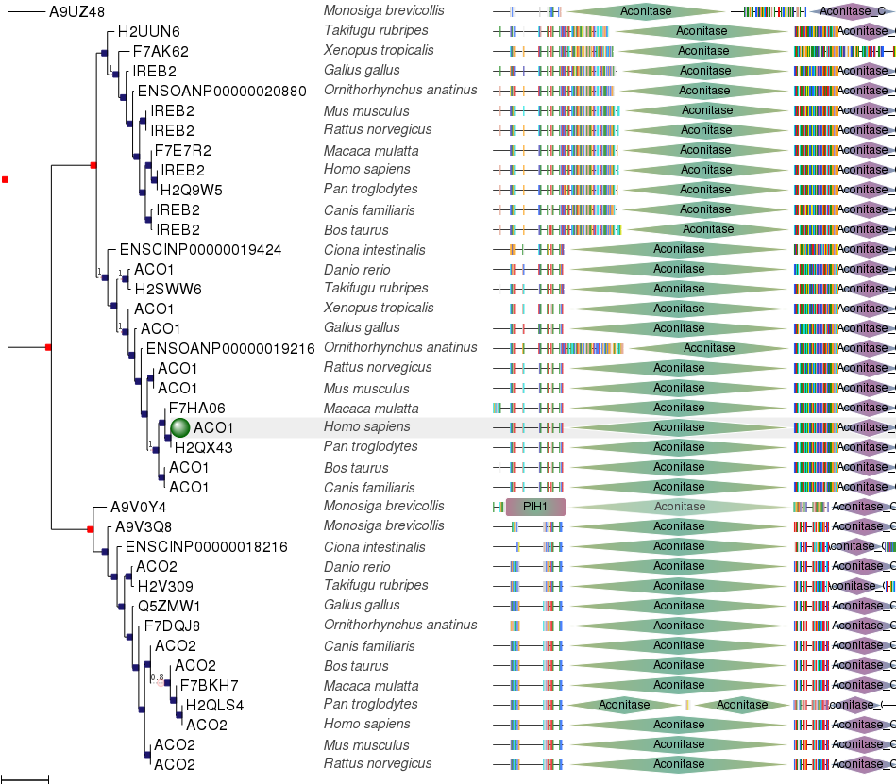Филогенетично дърво

### Ancestor Chart



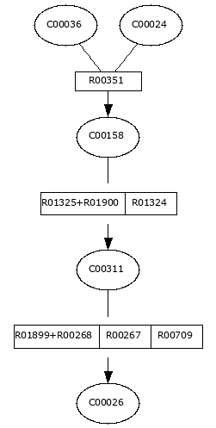

[**dsDNA**](https://reactome.org/content/detail/R-HSA-5649637)

**Identifier:** R-HSA-5649637

**Species:** Homo sapiens

**Compartment:** nucleoplasm

**Cellular Component**

##### Definition ([GO:0005654 GONUTS page](http://gowiki.tamu.edu/wiki/index.php/Category:GO:0005654))

That part of the nuclear content other than the chromosomes or the nucleolus.

<https://www.uniprot.org>

|  |  |
| --- | --- |
| Entry namei | H2QX43_PANTR |
| Accessioni | Primary (citable) accession number: **H2QX43** Secondary accession number(s): A0A2J8QSQ2 |
| Entry statusi | Unreviewed (UniProtKB/TrEMBL) |
|  |  |

**Citrate cycle (TCA cycle) - Pan troglodytes (chimpanzee)**

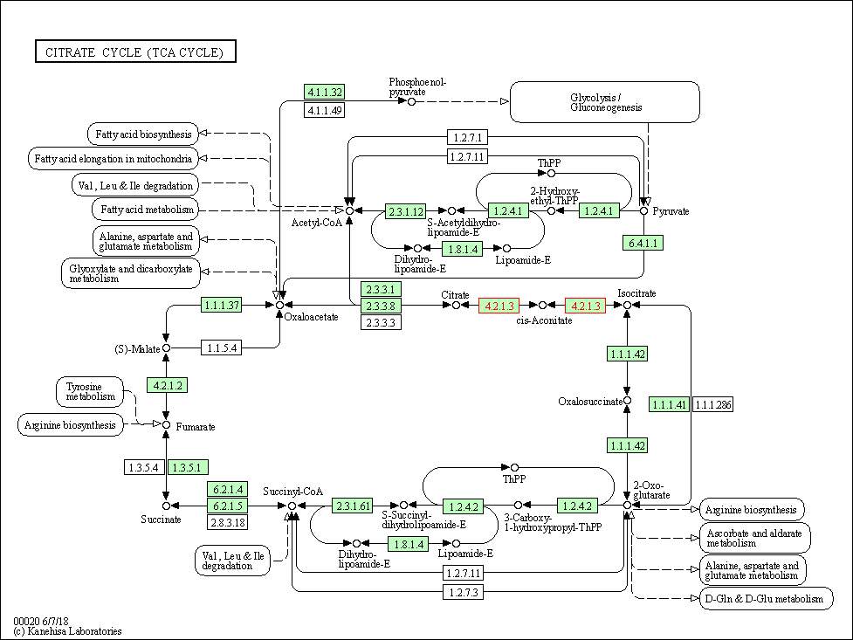

|  |  |
| --- | --- |
| [ko00630](https://www.genome.jp/kegg-bin/show_pathway?ko00630+K01681) | Glyoxylate and dicarboxylate metabolism |

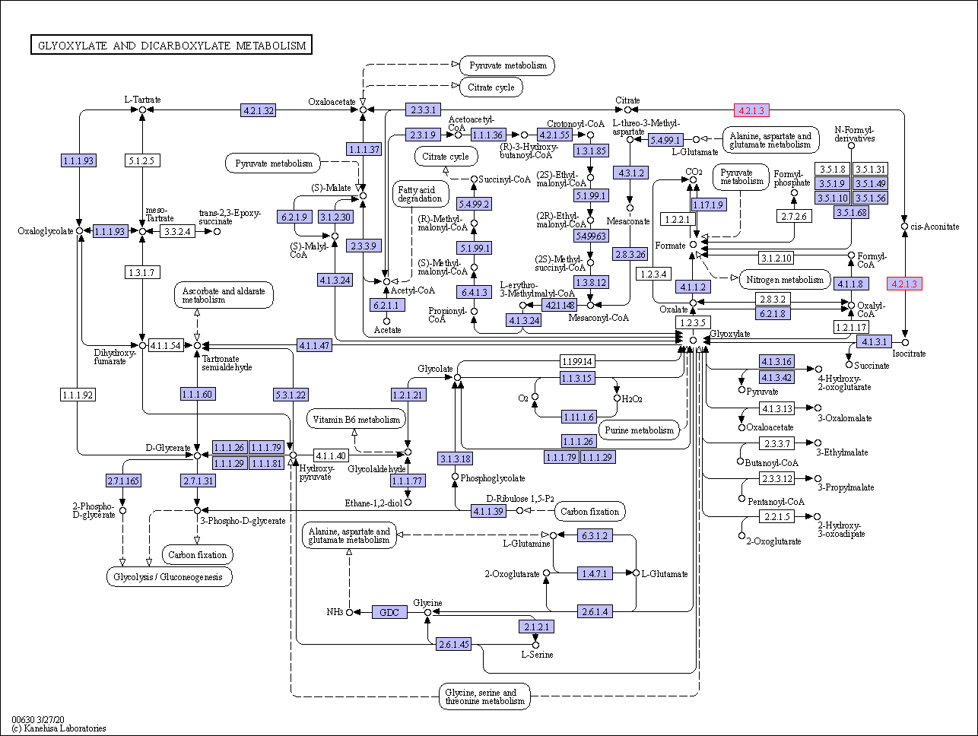

<https://pfam.xfam.org/>

**Aconitase** (aconitate hydratase; [EC](https://en.wikipedia.org/wiki/Enzyme_Commission_number) [4.2.1.3](https://enzyme.expasy.org/EC/4.2.1.3)) is an enzyme that catalyses the [stereo-specific](https://en.wikipedia.org/wiki/Stereochemistry) [isomerization](https://en.wikipedia.org/wiki/Isomerization) of [citrate](https://en.wikipedia.org/wiki/Citrate) to [isocitrate](https://en.wikipedia.org/wiki/Isocitrate) via cis-[aconitate](https://en.wikipedia.org/wiki/Aconitate" \o "Aconitate) in the [tricarboxylic acid cycle](https://en.wikipedia.org/wiki/Tricarboxylic_acid_cycle), a non-[redox](https://en.wikipedia.org/wiki/Redox)-active process.[[3]](https://pfam.xfam.org/family/PF00330#cite_note-pmid8262329-3)[[4]](https://pfam.xfam.org/family/PF00330#cite_note-pmid11848829-4)[[5]](https://pfam.xfam.org/family/PF00330#cite_note-pmid11848830-5)

## Structure

Aconitase, displayed in the structures in the right margin of this page, has two slightly different structures, depending on whether it is activated or inactivated.[[6]](https://pfam.xfam.org/family/PF00330#cite_note-inactive_structure-6)[[7]](https://pfam.xfam.org/family/PF00330#cite_note-active_structure-7) In the inactive form, its structure is divided into four domains.[[6]](https://pfam.xfam.org/family/PF00330#cite_note-inactive_structure-6) Counting from the [N-terminus](https://en.wikipedia.org/wiki/N-terminus), only the first three of these domains are involved in close interactions with the [3Fe-4S] cluster, but the [active site](https://en.wikipedia.org/wiki/Active_site) consists of residues from all four domains, including the larger [C-terminal](https://en.wikipedia.org/wiki/C-terminal) domain.[[6]](https://pfam.xfam.org/family/PF00330#cite_note-inactive_structure-6) The Fe-S cluster and a SO42âˆ’ anion also reside in the active site.[[6]](https://pfam.xfam.org/family/PF00330#cite_note-inactive_structure-6) When the enzyme is activated, it gains an additional iron atom, creating a [4Fe-4S] cluster.[[7]](https://pfam.xfam.org/family/PF00330#cite_note-active_structure-7)[[8]](https://pfam.xfam.org/family/PF00330#cite_note-extra_structure-8) However, the structure of the rest of the enzyme is nearly unchanged; the conserved atoms between the two forms are in essentially the same positions, up to a difference of 0.1 angstroms.[[7]](https://pfam.xfam.org/family/PF00330#cite_note-active_structure-7)

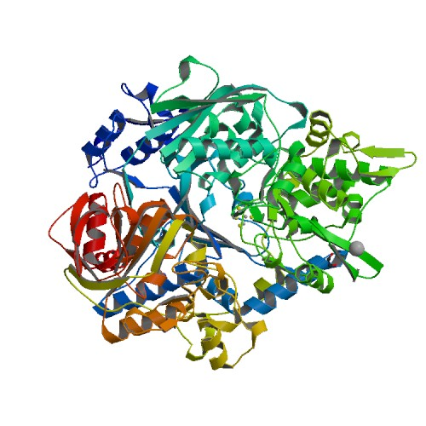

Втора секвенция

MPSQVIPEKQKAIVFYETDGKLEYKDVTVPEPKPNEILVHVKYSGVCHSDLHAWHGDWPF

QLKFPLIGGHEGAGVVVKLGSNVKGWKVGDFAGIKWLNGTCMSCEYCEVGNESQCPYLDG

TGFTHDGTFQEYATADAVQAAHIPPNVNLAEVAPILCAGITVYKALKRANVIPGQWVTIS

GACGGLGSLAIQYALAMGYRVIGIDGGNAKRKLFEQLGGEIFIDFTEEKDIVGAIIKATN

GGSHGVINVSVSEAAIEASTRYCRPNGTVVLVGMPAHAYCNSDVFNQVVKSISIVGSCVG

NRADTREALDFFARGLIKSPIHLAGLSDVPEIFAKMEKGEIVGRYVVETSK

NCBI

alcohol dehydrogenase ADH5 [Saccharomyces cerevisiae S288C]

Query 1 MPSQVIPEKQKAIVFYETDGKLEYKDVTVPEPKPNEILVHVKYSGVCHSDLHAWHGDWPF 60

MPSQVIPEKQKAIVFYETDGKLEYKDVTVPEPKPNEILVHVKYSGVCHSDLHAWHGDWPF

Sbjct 1 MPSQVIPEKQKAIVFYETDGKLEYKDVTVPEPKPNEILVHVKYSGVCHSDLHAWHGDWPF 60

Query 61 QLKFPLIGGHEGAGVVVKLGSNVKGWKVGDFAGIKWLNGTCMSCEYCEVGNESQCPYLDG 120

QLKFPLIGGHEGAGVVVKLGSNVKGWKVGDFAGIKWLNGTCMSCEYCEVGNESQCPYLDG

Sbjct 61 QLKFPLIGGHEGAGVVVKLGSNVKGWKVGDFAGIKWLNGTCMSCEYCEVGNESQCPYLDG 120

Query 121 TGFTHDGTFQEYATADAVQAAHIPPNVNLAEVAPILCAGITVYKALKRANVIPGQWVTIS 180

TGFTHDGTFQEYATADAVQAAHIPPNVNLAEVAPILCAGITVYKALKRANVIPGQWVTIS

Sbjct 121 TGFTHDGTFQEYATADAVQAAHIPPNVNLAEVAPILCAGITVYKALKRANVIPGQWVTIS 180

Query 181 GACGGLGSLAIQYALAMGYRVIGIDGGNAKRKLFEQLGGEIFIDFTEEKDIVGAIIKATN 240

GACGGLGSLAIQYALAMGYRVIGIDGGNAKRKLFEQLGGEIFIDFTEEKDIVGAIIKATN

Sbjct 181 GACGGLGSLAIQYALAMGYRVIGIDGGNAKRKLFEQLGGEIFIDFTEEKDIVGAIIKATN 240

Query 241 GGSHGVINVSVSEAAIEASTRYCRPNGTVVLVGMPAHAYCNSDVFNQVVKSISIVGSCVG 300

GGSHGVINVSVSEAAIEASTRYCRPNGTVVLVGMPAHAYCNSDVFNQVVKSISIVGSCVG

Sbjct 241 GGSHGVINVSVSEAAIEASTRYCRPNGTVVLVGMPAHAYCNSDVFNQVVKSISIVGSCVG 300

Query 301 NRADTREALDFFARGLIKSPIHLAGLSDVPEIFAKMEKGEIVGRYVVETSK 351

NRADTREALDFFARGLIKSPIHLAGLSDVPEIFAKMEKGEIVGRYVVETSK

Sbjct 301 NRADTREALDFFARGLIKSPIHLAGLSDVPEIFAKMEKGEIVGRYVVETSK 351

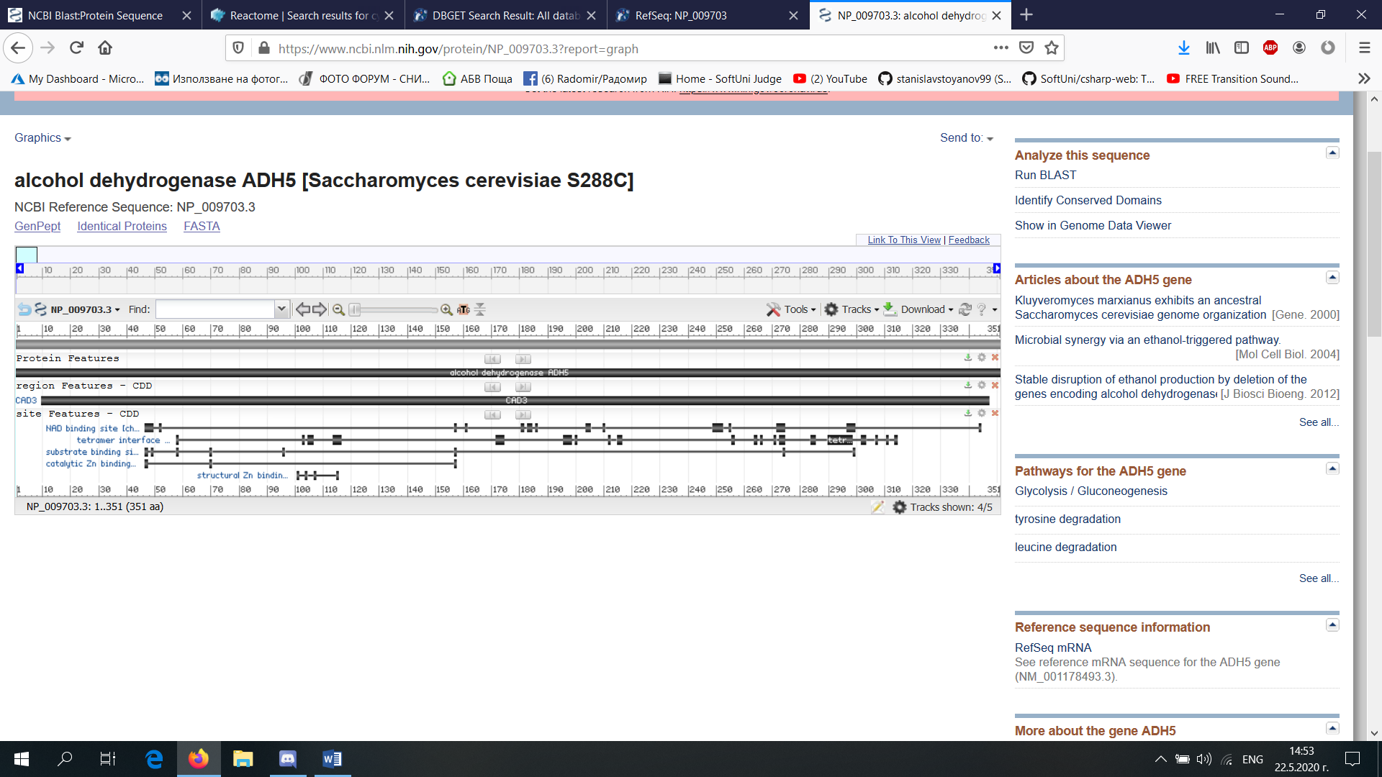

<https://www.genome.jp>

|  |  |  |  |
| --- | --- | --- | --- |
| **Entry** | |  |  | | --- | --- | | YBR145W           CDS       [T00005](https://www.genome.jp/kegg-bin/show_organism?org=T00005) |  | |
| **Gene name** | ADH5 |
| **Definition** | (RefSeq) alcohol dehydrogenase ADH5 |
| **KO** | |  |  | | --- | --- | | [K13953](https://www.genome.jp/dbget-bin/www_bget?ko:K13953) | alcohol dehydrogenase, propanol-preferring [EC:[1.1.1.1](https://www.genome.jp/dbget-bin/www_bget?ec:1.1.1.1)] | |
| **Organism** | [sce](https://www.genome.jp/kegg-bin/show_organism?org=sce)  Saccharomyces cerevisiae (budding yeast) |
| **Pathway** | |  |  | | --- | --- | | [sce00010](https://www.genome.jp/kegg-bin/show_pathway?sce00010+YBR145W) | Glycolysis / Gluconeogenesis |  |  |  | | --- | --- | | [sce00071](https://www.genome.jp/kegg-bin/show_pathway?sce00071+YBR145W) | Fatty acid degradation |  |  |  | | --- | --- | | [sce00350](https://www.genome.jp/kegg-bin/show_pathway?sce00350+YBR145W) | Tyrosine metabolism |  |  |  | | --- | --- | | [sce01100](https://www.genome.jp/kegg-bin/show_pathway?sce01100+YBR145W) | Metabolic pathways |  |  |  | | --- | --- | | [sce01110](https://www.genome.jp/kegg-bin/show_pathway?sce01110+YBR145W) | Biosynthesis of secondary metabolites | |

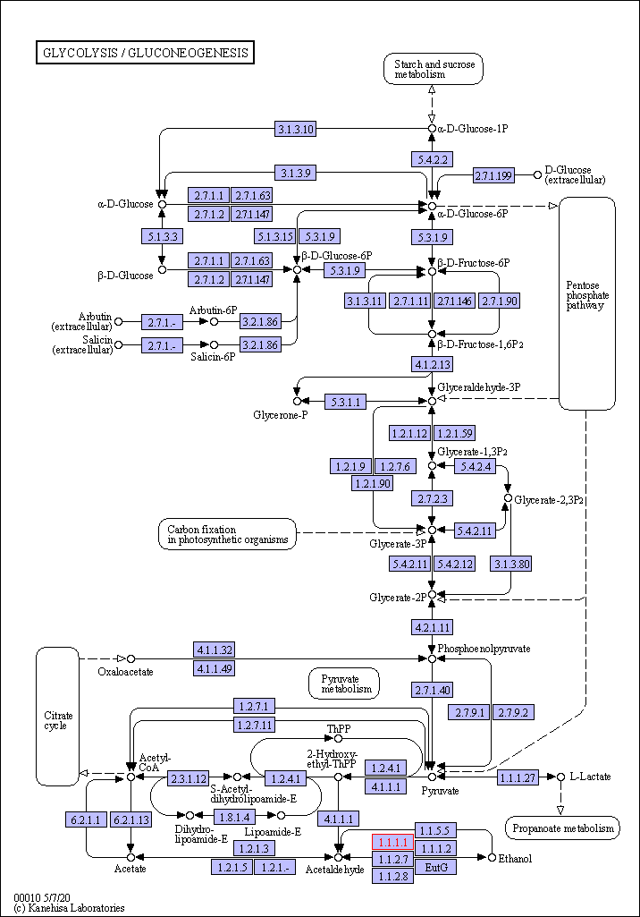

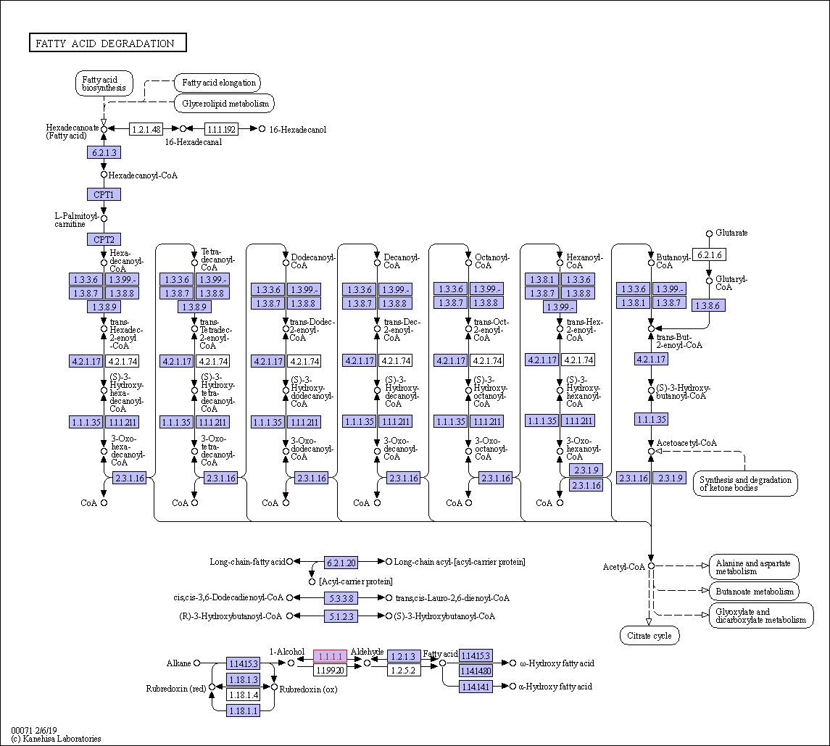

<https://www.genome.jp/dbget-bin/www_bget?ec:1.1.1.1>

<https://www.uniprot.org>

## UniProtKB - P38113 (ADH5_YEAST)

## Functioni

#### Miscellaneous

Present with 1310 molecules/cell in log phase SD medium.

<https://reactome.org>

[**ADH5**](https://reactome.org/content/detail/R-HSA-5692235)

**Identifier:** R-HSA-5692235

**Species:** Homo sapiens

**Compartment:** cytosol

**Primary external reference:** UniProt: [ADH5: P11766](https://purl.uniprot.org/uniprot/P11766)

### Ancestor Chart



[**ADH6**](https://reactome.org/content/detail/R-HSA-71747)

**Identifier:** R-HSA-71747

**Species:** Homo sapiens

**Compartment:** cytosol

**Primary external reference:** UniProt: [ADH6: P28332](https://purl.uniprot.org/uniprot/P28332)

[**ADH1A**](https://reactome.org/content/detail/R-HSA-71692)

**Identifier:** R-HSA-71692

**Species:** Homo sapiens

**Compartment:** cytosol

**Primary external reference:** UniProt: [ADH1A: P07327](https://purl.uniprot.org/uniprot/P07327)

### [Chemical Compound](https://reactome.org/content/query?q=alcohol+dehydrogenase+ADH5+%5bSaccharomyces+cerevisiae+S288C%5d&species=Homo+sapiens&species=Entries+without+species&types=Chemical%20Compound&cluster=true)

[**Alcohol**](https://reactome.org/content/detail/R-ALL-8878776)

**Identifier:** R-ALL-8878776

**Compartment:** extracellular region

**Primary external reference:** ChEBI: [alcohol: 30879](http://www.ebi.ac.uk/chebi/searchId.do?chebiId=CHEBI:30879)

[**ARACOH**](https://reactome.org/content/detail/R-ALL-5696426)

**Identifier:** R-ALL-5696426

**Compartment:** endoplasmic reticulum lumen

**Primary external reference:** ChEBI: [icosan-1-ol: 75627](http://www.ebi.ac.uk/chebi/searchId.do?chebiId=CHEBI:75627)

[**MePeOH**](https://reactome.org/content/detail/R-ALL-196066)

**Identifier:** R-ALL-196066

**Compartment:** cytosol

**Primary external reference:** ChEBI: [4-methylpentan-1-ol: 63910](http://www.ebi.ac.uk/chebi/searchId.do?chebiId=CHEBI:63910)

<https://www.ncbi.nlm.nih.gov/gene/852442>

Genomic Context describing neighboring genes

<https://pfam.xfam.org/family/PF00107>

# Family: ADH_zinc_N (PF00107)

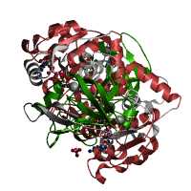

<https://www.ncbi.nlm.nih.gov/genome/gdv/browser/Protein/?id=NP_009703.3>

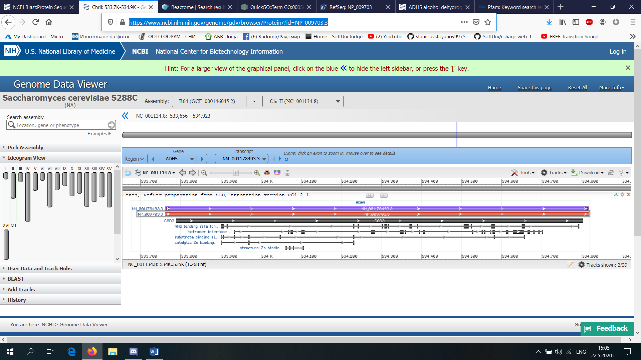

Трета секвенция

atgagcaacccattcgcacaccttgctgagccattggatcctgtacaaccaggaaagaaa

ttcttcaatttgaataaattggaggattcaagatatgggcgcttaccattttcgatcaga

gttcttctggaagcagccattcggaattgtgatgagtttttggtgaagaaacaggatatt

gaaaatattctacattggaatgtcacgcagcacaagaacatagaagtgccatttaagcct

gctcgtgtcatcctgcaggactttacgggtgtgcccgctgtggttgactttgctgcaatg

cgtgatgctgtgaaaaagttaggaggagatccagagaaaataaaccctgtctgccctgct

gatcttgtaatagatcattccatccaggttgatttcaacagaagggcagacagtttacag

aagaatcaagacctggaatttgaaagaaatagagagcgatttgaatttttaaagtggggt

tcccaggcttttcacaacatgcggattattccccctggctcaggaatcatccaccaggtg

aatttggaatatttggcaagagtggtatttgatcaggatggatattattacccagacagc

ctcgtgggcacagactcgcacactaccatgattgatggcttgggcattcttggttggggt

gtcggtggtattgaagcagaagctgtcatgctgggtcagccaatcagtatggtgcttcct

caggtgattggctacaggctgatggggaagccccaccctctggtaacatccactgacatc

gtgctcaccattaccaagcacctccgccaggttggggtagtgggcaaatttgtcgagttc

ttcgggcctggagtagcccagttgtccattgctgaccgagctacgattgctaacatgtgt

ccagagtacggagcaactgctgcctttttcccagttgatgaagttagtatcacgtacctg

gtgcaaacaggtcgtgatgaagaaaaattaaagtatattaaaaaatatcttcaggctgta

ggaatgtttcgagatttcaatgacccttctcaagacccagacttcacccaggttgtggaa

ttagatttgaaaacagtagtgccttgctgtagtggacccaaaaggcctcaggacaaagtt

gctgtgtccgacatgaaaaaggactttgagagctgccttggagccaagcaaggatttaaa

ggattccaagttgctcctgaacatcataatgaccataagacctttatctatgataacact

gaattcacccttgctcatggttctgtggtcattgctgccattactagctgcacaaacacc

agtaatccgtctgtgatgttaggggcaggattgttagcaaagaaagctgtggatgctggc

ctgaacgtgatgccttacatcaaaactagcctgtctcctgggagtggcgtggtcacctac

tacctacaagaaagcggagtcatgccttatctgtctcagcttgggtttgacgtggtgggc

tatggctgcatgacctgcattggcaacagtgggcctttacctgaacctgtggtagaagcc

atcacacagggagaccttgtagctgttggagtactatctggaaacaggaattttgaaggt

cgagttcaccccaacacccgggccaactatttagcctctccccccttagtaatagcatat

gcaattgctggaaccatcagaatcgactttgagaaagagccattgggagtaaatgcaaag

ggacagcaggtatttctgaaagatatctggccgactagagacgagatccaggcagtggag

cgtcagtatgtcatcccggggatgtttaaggaagtctatcagaaaatagagactgtgaat

gaaagctggaatgccttagcaaccccatcagataagctgtttttctggaattccaaatct

acgtatatcaaatcaccaccattctttgaaaacctgactttggatcttcagccccctaaa

tctatagtggatgcctatgtgctgctaaatttgggagattcggtaacaactgaccacatc

tccccagctggaaatattgcaagaaacagtcctgctgctcgctacttaactaacagaggc

ctaactccacgagaattcaactcctatggctcccgccgaggtaatgacgccgtcatggca

cggggaacatttgccaacattcgcttgttaaacagatttttgaacaagcaggcaccacag

actatccatctgccttctggggaaatccttgatgtgtttgatgctgctgagcggtaccag

caggcaggccttcccctgatcgttctggctggcaaagagtacggtgcaggcagctcccga

gactgggcagctaagggccctttcctgctgggaatcaaagccgtcctggccgagagctac

gagcgcattcaccgcagtaacctggttgggatgggtgtgatcccacttgaatatctccct

ggtgagaatgcagatgccctggggctcacagggcaagaacgatacactatcattattcca

gaaaacctcaaaccacaaatgaaagtccaggtcaagctggatactggcaagaccttccag

gctgtcatgaggtttgacactgatgtggagctcacttatttcctcaacgggggcatcctc

aactacatgatccgcaagatggccaagtag

NCBI

Homo sapiens aconitase 1 (ACO1), transcript variant 3, mRNA

<https://blast.ncbi.nlm.nih.gov/Blast.cgi#alnHdr_1676325188>

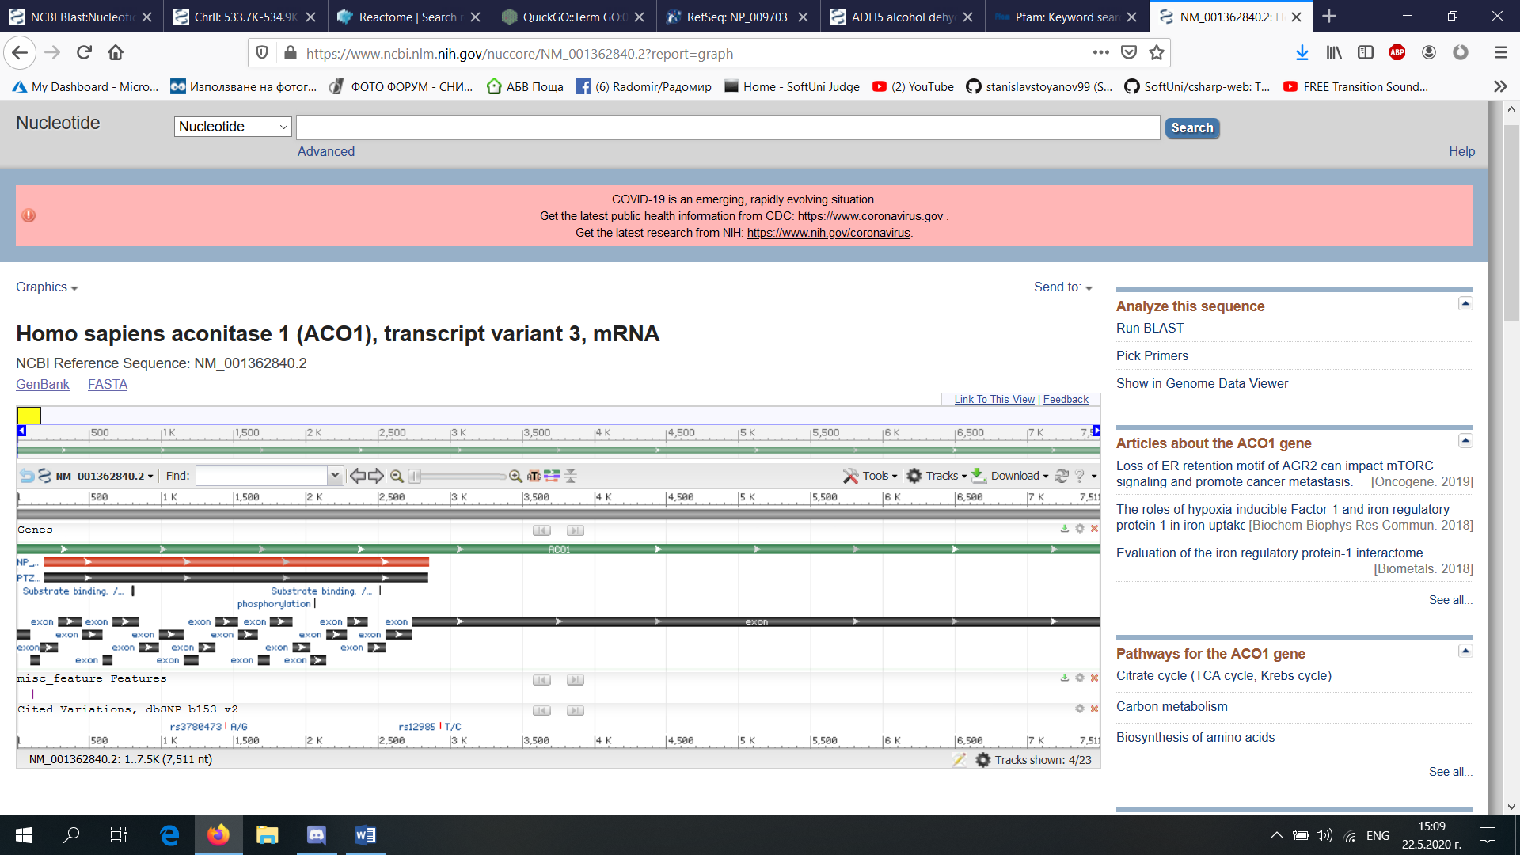

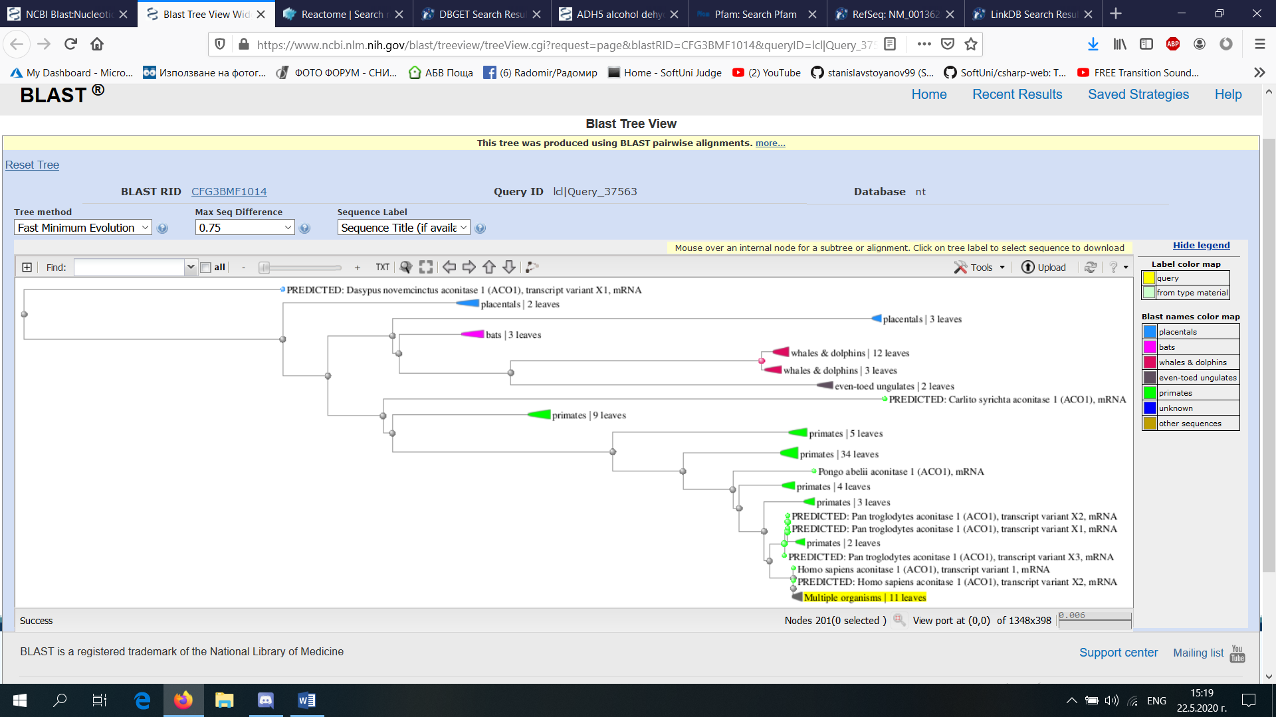

<https://www.genome.jp>

|  |  |  |  |
| --- | --- | --- | --- |
| **Entry** | |  |  | | --- | --- | | 48                CDS       [T01001](https://www.genome.jp/kegg-bin/show_organism?org=T01001) |  | |
| **Gene name** | ACO1, ACONS, HEL60, IREB1, IREBP, IREBP1, IRP1 |
| **Definition** | (RefSeq) aconitase 1 |
| **KO** | |  |  | | --- | --- | | [K01681](https://www.genome.jp/dbget-bin/www_bget?ko:K01681) | aconitate hydratase [EC:[4.2.1.3](https://www.genome.jp/dbget-bin/www_bget?ec:4.2.1.3)] | |
| **Organism** | [hsa](https://www.genome.jp/kegg-bin/show_organism?org=hsa)  Homo sapiens (human) |
| **Pathway** | |  |  | | --- | --- | | [hsa00020](https://www.genome.jp/kegg-bin/show_pathway?hsa00020+48) | Citrate cycle (TCA cycle) |  |  |  | | --- | --- | | [hsa00630](https://www.genome.jp/kegg-bin/show_pathway?hsa00630+48) | Glyoxylate and dicarboxylate metabolism |  |  |  | | --- | --- | | [hsa01100](https://www.genome.jp/kegg-bin/show_pathway?hsa01100+48) | Metabolic pathways |  |  |  | | --- | --- | | [hsa01200](https://www.genome.jp/kegg-bin/show_pathway?hsa01200+48) | Carbon metabolism |  |  |  | | --- | --- | | [hsa01210](https://www.genome.jp/kegg-bin/show_pathway?hsa01210+48) | 2-Oxocarboxylic acid metabolism |  |  |  | | --- | --- | | [hsa01230](https://www.genome.jp/kegg-bin/show_pathway?hsa01230+48) | Biosynthesis of amino acids | |

|  |  |  |  |
| --- | --- | --- | --- |
| **Entry** | |  |  | | --- | --- | | K01681                      KO |  | |
| **Name** | ACO, acnA |
| **Definition** | aconitate hydratase [EC:[4.2.1.3](https://www.genome.jp/dbget-bin/www_bget?ec:4.2.1.3)] |
| **Pathway** | |  |  | | --- | --- | | [ko00020](https://www.genome.jp/kegg-bin/show_pathway?ko00020+K01681) | Citrate cycle (TCA cycle) |  |  |  | | --- | --- | | [ko00630](https://www.genome.jp/kegg-bin/show_pathway?ko00630+K01681) | Glyoxylate and dicarboxylate metabolism |  |  |  | | --- | --- | | [ko00720](https://www.genome.jp/kegg-bin/show_pathway?ko00720+K01681) | Carbon fixation pathways in prokaryotes |  |  |  | | --- | --- | | [ko01100](https://www.genome.jp/kegg-bin/show_pathway?ko01100+K01681) | Metabolic pathways |  |  |  | | --- | --- | | [ko01110](https://www.genome.jp/kegg-bin/show_pathway?ko01110+K01681) | Biosynthesis of secondary metabolites |  |  |  | | --- | --- | | [ko01120](https://www.genome.jp/kegg-bin/show_pathway?ko01120+K01681) | Microbial metabolism in diverse environments |  |  |  | | --- | --- | | [ko01200](https://www.genome.jp/kegg-bin/show_pathway?ko01200+K01681) | Carbon metabolism |  |  |  | | --- | --- | | [ko01210](https://www.genome.jp/kegg-bin/show_pathway?ko01210+K01681) | 2-Oxocarboxylic acid metabolism |  |  |  | | --- | --- | | [ko01230](https://www.genome.jp/kegg-bin/show_pathway?ko01230+K01681) | Biosynthesis of amino acids | |

|  |  |  |  |
| --- | --- | --- | --- |
| **Entry** | |  |  | | --- | --- | | EC 4.2.1.3                  Enzyme |  | |
| **Name** | aconitate hydratase; cis-aconitase; aconitase; AcnB; 2-methylaconitate hydratase; citrate(isocitrate) hydro-lyase |
| **Class** | Lyases; Carbon-oxygen lyases; Hydro-lyases [BRITE hierarchy](https://www.genome.jp/kegg-bin/get_htext?htext=ko01000&option=-a&query=4.2.1.3) |

<https://www.uniprot.org>

## UniProtKB - P21399 (ACOC_HUMAN)

## Functioni

Iron sensor. Binds a 4Fe-4S cluster and functions as aconitase when cellular iron levels are high. Functions as mRNA binding protein that regulates uptake, sequestration and utilization of iron when cellular iron levels are low. Binds to iron-responsive elements (IRES) in target mRNA species when iron levels are low. Binding of a 4Fe-4S cluster precludes RNA binding.

*

<https://reactome.org/>

### [RNA Sequence](https://reactome.org/content/query?q=Homo+sapiens+aconitase+1+(ACO1)%2c+transcript+variant+3%2c+mRNA&species=Homo+sapiens&species=Entries+without+species&types=RNA%20Sequence&cluster=true) (2 results from a total of 229)

#### [p14ARF mRNA](https://reactome.org/content/detail/R-HSA-3209107)

**Identifier:** R-HSA-3209107

**Species:** Homo sapiens

**Compartment:** cytosol

**Primary external reference:** ENSEMBL: [CDKN2A Transcript Variant 4: ENST00000579755](http://www.ensembl.org/Homo_sapiens/transview?transcript=ENST00000579755;db=core)

#### [p16INK4A mRNA](https://reactome.org/content/detail/R-HSA-3209105)

**Identifier:** R-HSA-3209105

**Species:** Homo sapiens

**Compartment:** cytosol

**Primary external reference:** ENSEMBL: [CDKN2A Transcript Variant 1: ENST00000304494](http://www.ensembl.org/Homo_sapiens/transview?transcript=ENST00000304494;db=core)

### [Protein](https://reactome.org/content/query?q=Homo+sapiens+aconitase+1+(ACO1)%2c+transcript+variant+3%2c+mRNA&species=Homo+sapiens&species=Entries+without+species&types=Protein&cluster=true) (2 results from a total of 25322)

#### [ACO1](https://reactome.org/content/detail/R-HSA-5690899)

**Identifier:** R-HSA-5690899

**Species:** Homo sapiens

**Compartment:** cytosol

**Primary external reference:** UniProt: [ACO1: P21399](https://purl.uniprot.org/uniprot/P21399)

#### [Variant lysozyme C](https://reactome.org/content/detail/R-HSA-976944)

**Identifier:** R-HSA-976944

**Species:** Homo sapiens

**Compartment:** extracellular region

**Primary external reference:** UniProt: [LYZ: P61626](https://purl.uniprot.org/uniprot/P61626)

Филогенетично дърво  
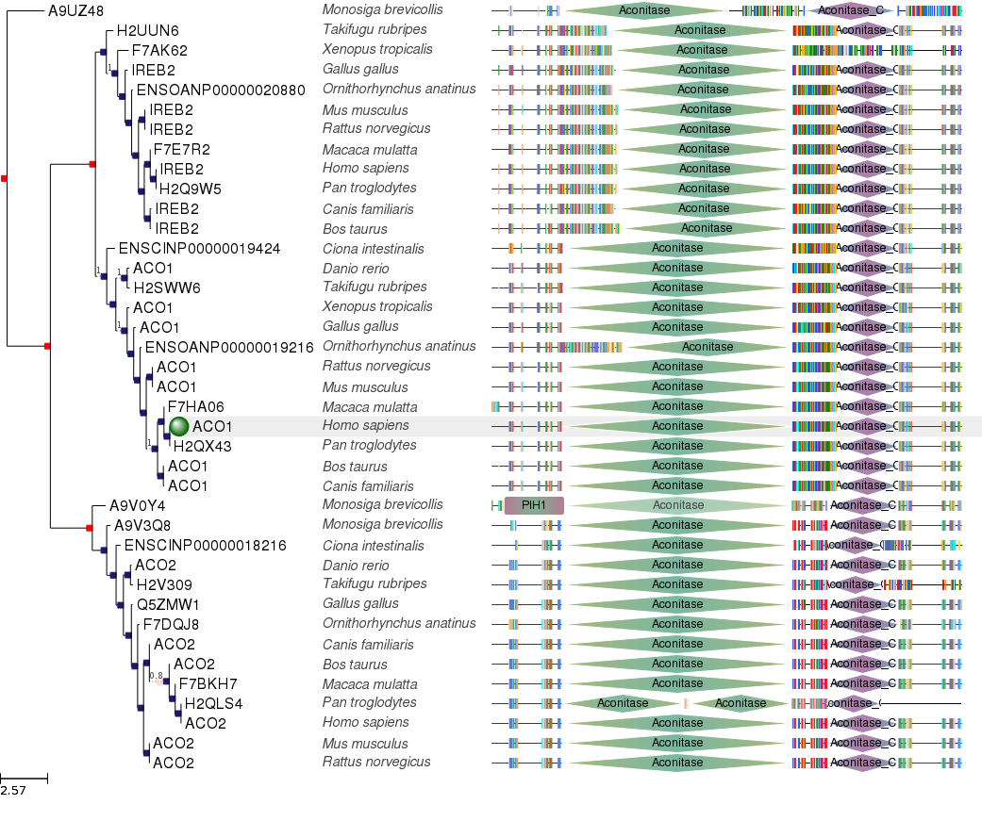

3D Structure - <https://swissmodel.expasy.org/repository/uniprot/P21399?csm=E1A05AF701D46DCB>

